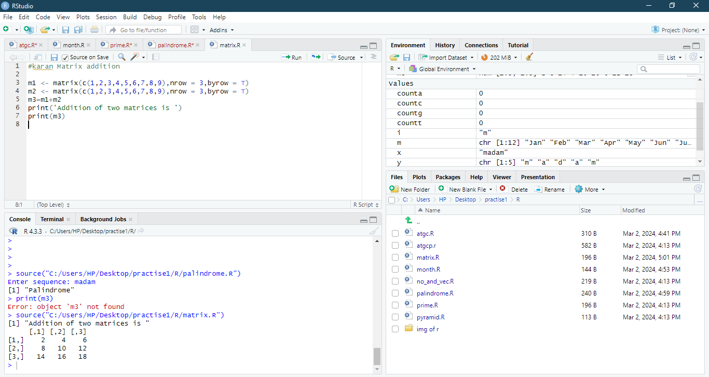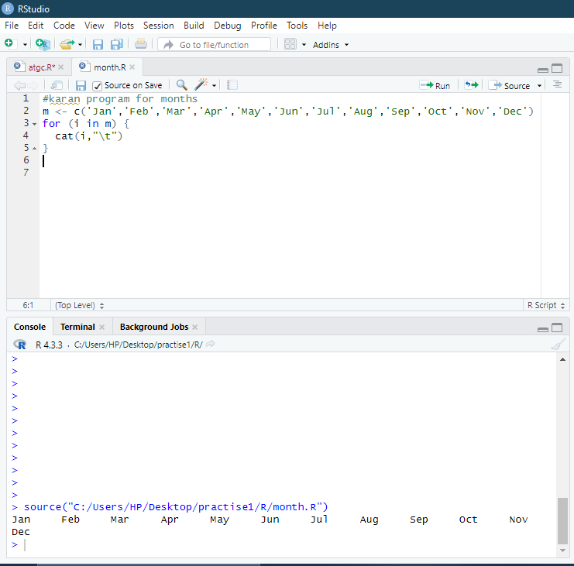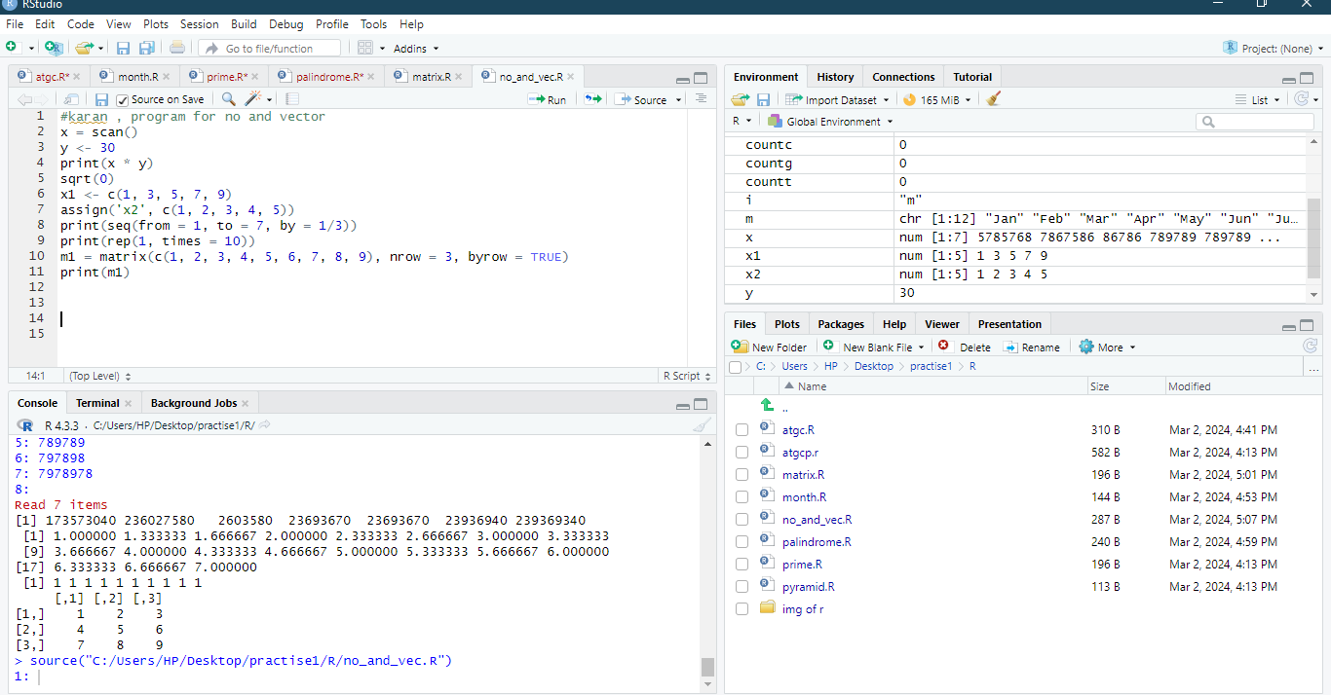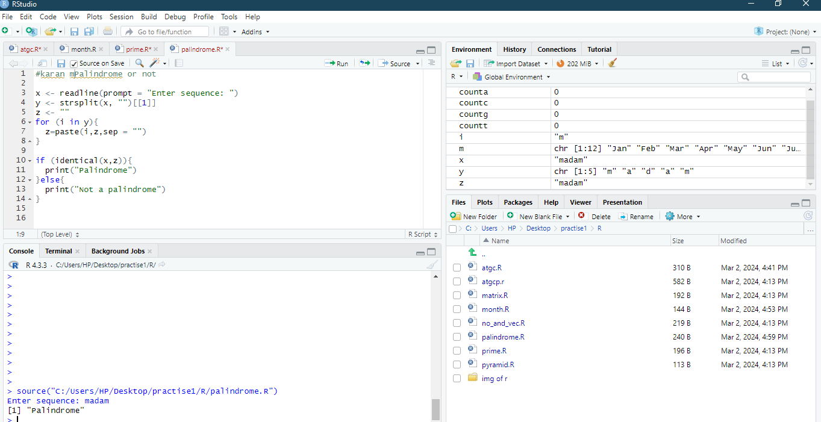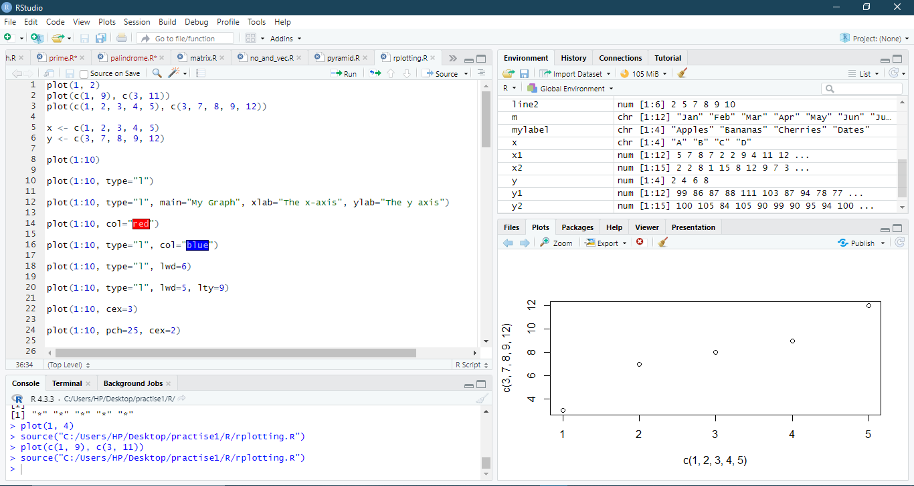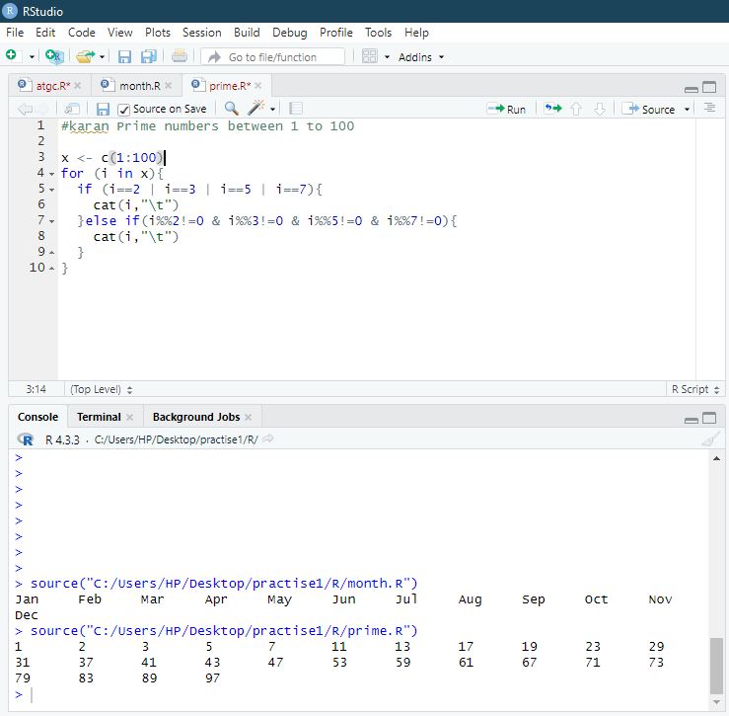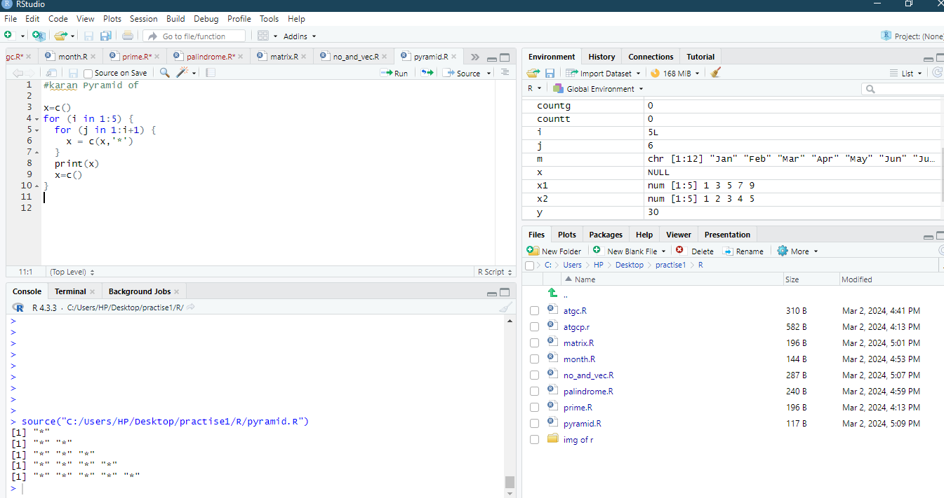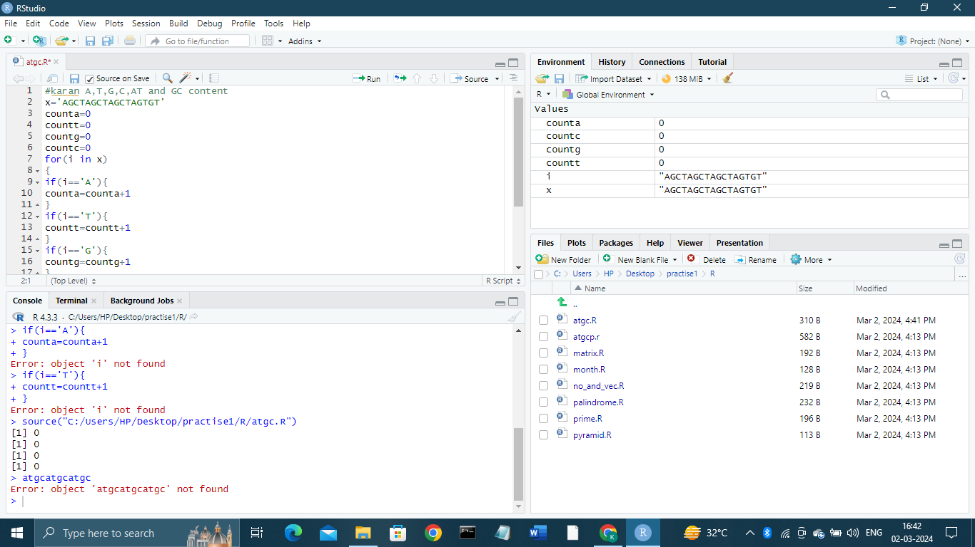

R Plotting

1. x <- c(5,4 ,3 ,2 ,1 )

y <- c(3, 1, 4, 7,9 )

plot(x,y)

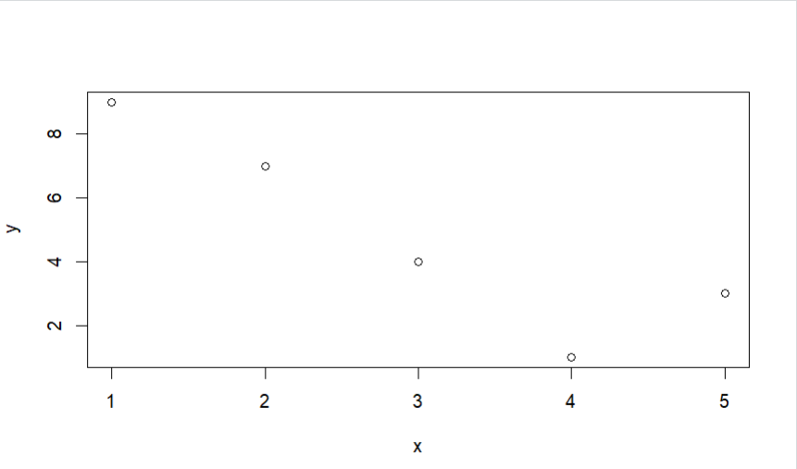

1. plot(0:12, type="l", lwd=5)

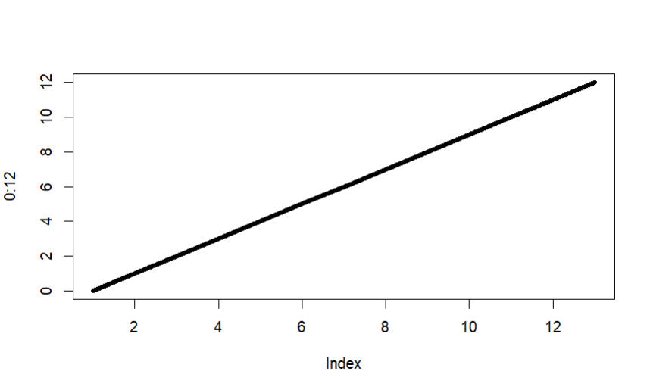

1. plot(0:12, type="l", lwd=7, lty=2)

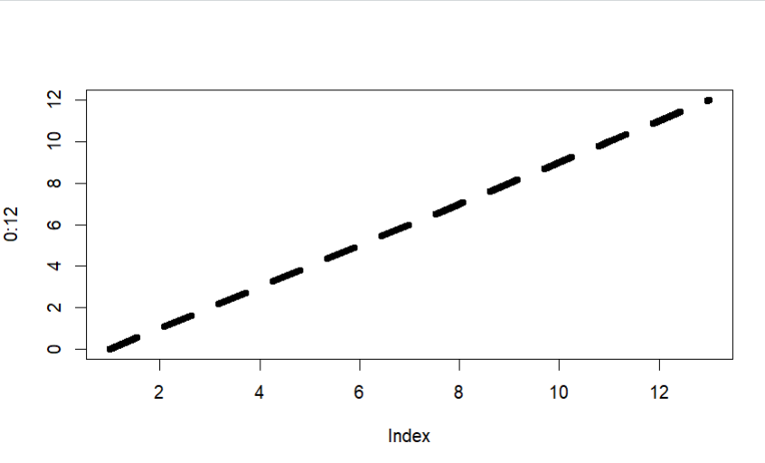

1. plot(0:12, cex=5)

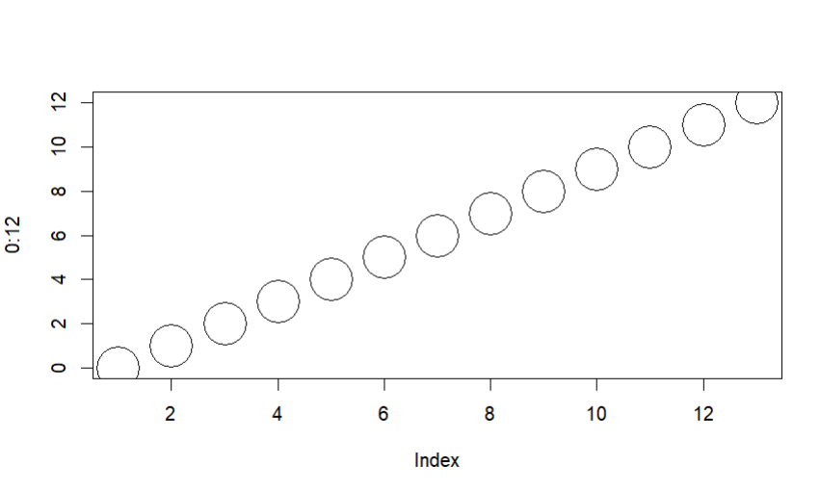

1. plot(0:10, pch=15, cex=6)

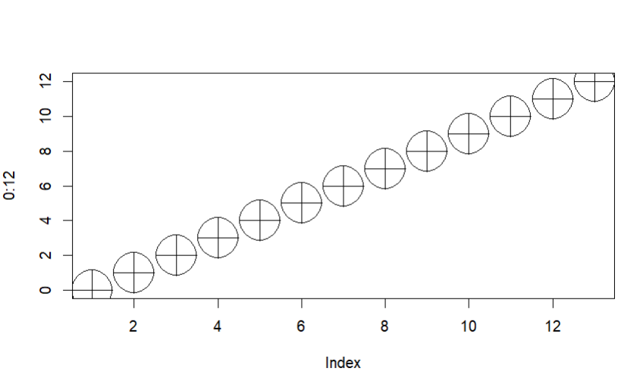

1. #multiple line

line1 <- c(2,4,6,8,10,12)

line2 <- c(1,3,5,7,9,11)

plot(line1, type = "l", col = "pink")

lines(line2, type="l", col = "purple")

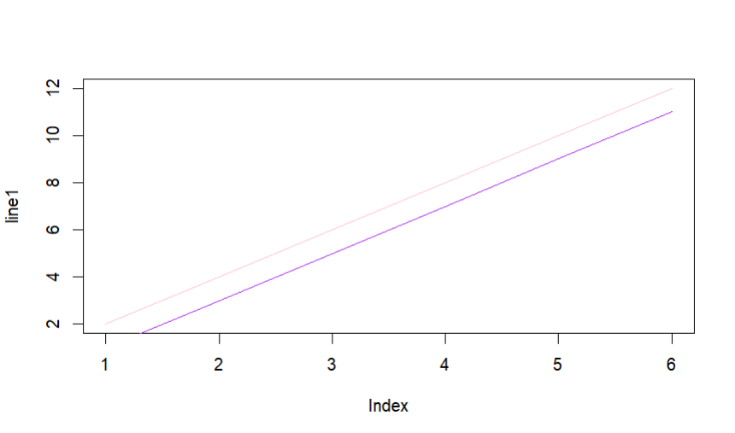

#scatterplot

x <- c(3,14,51,12,1,2,18,9,8,9,12,11)

y <- c(3,56,76,23,0,23,43,65,12,21,33,11)

plot(x, y, main="Electronic Devices", xlab="Sales", ylab="Year")

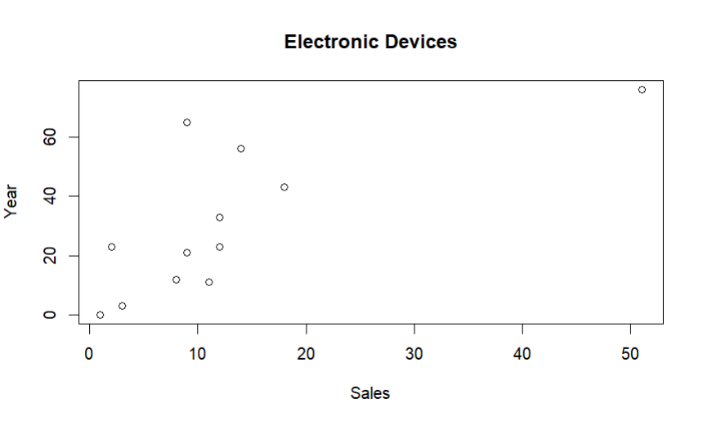

1. # day one, the age and speed of 12 cars:

x1 <- c(4,15,55,15,2,4,19,10,9,9,14,12)

y1 <- c(4,57,78,24,2,25,45,69,13,23,34,12)

# day two, the age and speed of 15 cars:

x2 <- c(5,16,56,16,3,5,20,14,37,81,91,15,70,14,14)

y2 <- c(5,58,26,25,90,19,72,25,34,17,99,12,97,82,45)

plot(x1, y1, main="Electronic Devices", xlab="Sales", ylab="Year", col="pink", cex=4)

points(x2, y2, col="purple", cex=4)

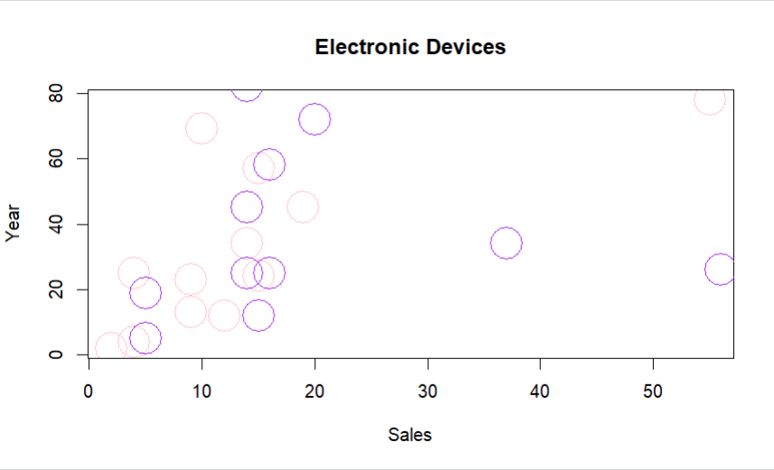

1. ##Pie Chart

# Create a vector of pies

x <- c(30,50,20,70)

# Display the pie chart

pie(x)

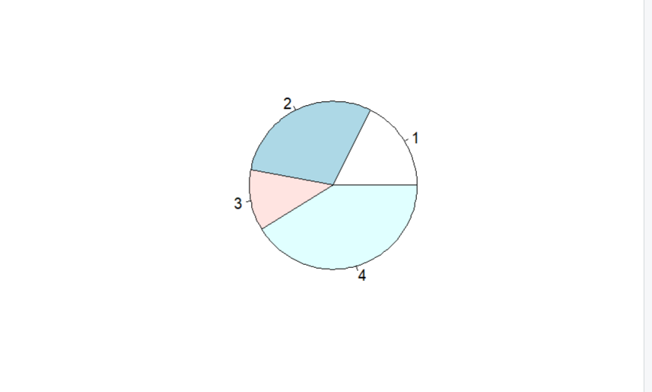

1. # Create a vector of pies

x <- c(30,60,70,50)

# Create a vector of labels

mylabel <- c("Guava", "Strawberry", "Cherry", "Kiwi")

# Display the pie chart with labels

pie(x, label = mylabel, main = "Fruits")

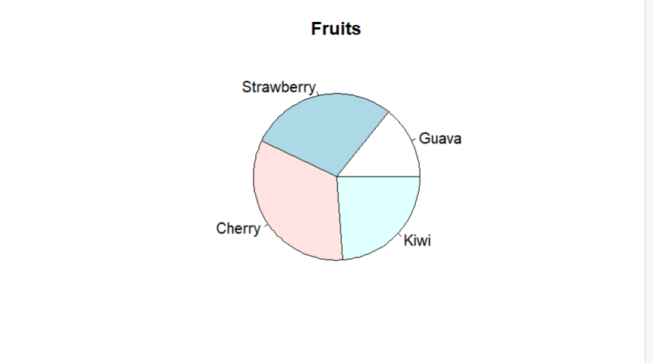

1. # Create a vector of colors

colors <- c("pink", "orange", "purple", "violet")

# Display the pie chart with colors

pie(x, label = mylabel, main = "Fruits", col = colors)

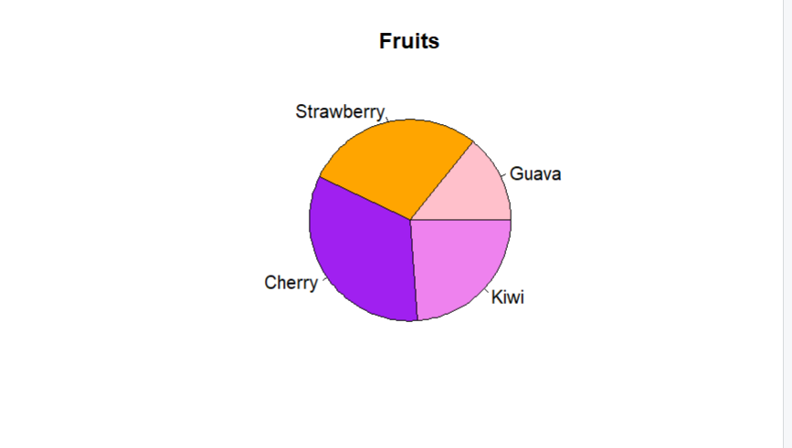

1. # Create a vector of labels

mylabel <- c("Guava", "Strawberry", "Cherry", "Kiwi")

# Create a vector of colors

colors <- c("pink", "orange", "purple", "violet")

# Display the pie chart with colors

pie(x, label = mylabel, main = "Pie Chart", col = colors)

# Display the explanation box

legend("bottomright", mylabel, fill = colors)

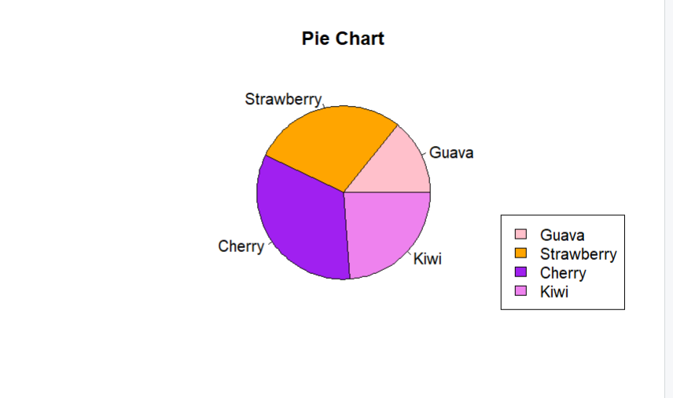

1. # x-axis values

x <- c("A", "B", "C", "D")

# y-axis values

y <- c(10, 6, 7, 8)

barplot(y, names.arg = x)

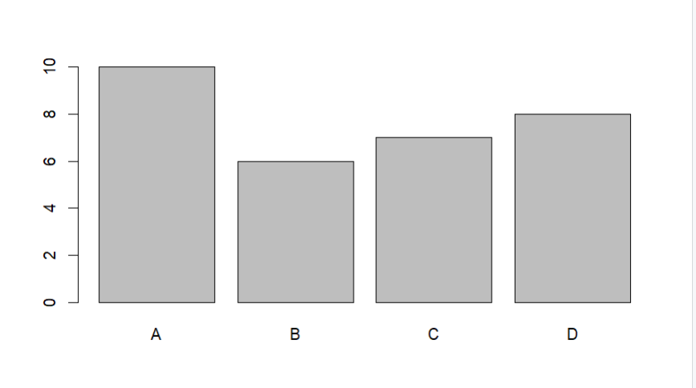

1. x <- c("A", "B", "C", "D")

y <- c(10, 6, 7, 8)

barplot(y, names.arg = x, col = "purple")

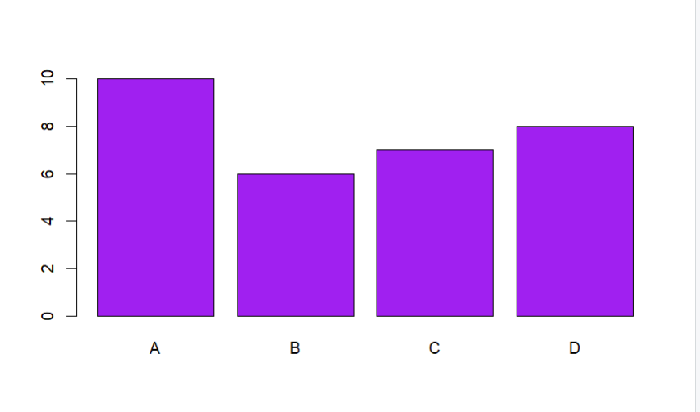

1. x <- c("A", "B", "C", "D")

y <- c(10, 6, 7, 8)

barplot(y, names.arg = x, horiz = TRUE)

